Honeycomb task analysis

This is documentation explaining the HCT. Code may be found in the HCT_analysis folder and can be run through HCT_pipeline.py (which is found in the main folder)

CONSINK ANALYSIS
Function: find_consinks_main.py
Inputs:
derivatives_base (Path): Path to derivatives folder
rel-dir_occ ("all trials" or "intervals"): which type of data to use for the rel dir occ
unit_type (UnitTypes): Types of units that will me used
methods (list): methods to use. See below for list
code_to_run (list): which code blocks to run. see explanantion below
goals_to_include (list): which goals to include in analysis. 0: rat going to g2 durin g1
speed_filt (bool: False): whether to use speedfiltered data
show_plots (bool: True): whether to show the plots
frame_rate (int: 25): frame rate of camera

Whereby we use the following methods:
Method 1: normalise the relative direction distribution by the control distribution based on the number of spikes fired at each platform (original method)
Method 2: normalise the relative direction distribution for each platform separately, then sum across platforms
Method 3: normalise the relative direction distribution by the control distribution based on the occupancy for the whole maze (not binned by platform)
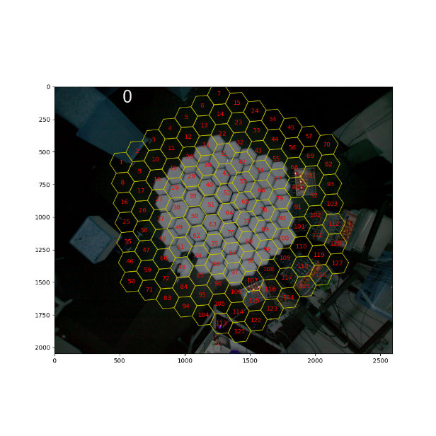
This code runs the analysis in the way that the platforms are the bins and we have 127 potential sinks, as shown on the right (see maze_overlay folder in derivatives_base)

I will go through the code here, paying attention to parts that are special and may be different than other code, so I won’t stand still at every line.

get_pos_data: returns positional data for the data for all the trials ('XY_HD_w_platforms.csv’) and for each goal as described in goals_to_include. If a goal is not in goals_to_include, it returns None. Suppose we are doing analysis on a two goal HCT animal and we want to look at the consinks for the whole trial. Then we could do that in two ways: taking the data for the fulltrial, or for G1+G2. If rel_dir_occ = “all trials” we do the former, if rel_dir_occ = “intervals”, we do the latter. Note that currently we don’t actually use the output of this, because we don’t plot the consink for the whole trial. But if we wanted to, we could add 3 to goals_to_include, and then we would run that.
Again, I won’t stand still at every function, just the ones that may need some explaining

path = rawsession_folder/'task_metadata'/'restricted_df_frames.csv'
if not path.exists:
turn_restricteddf_frames(derivatives_base, frame_rate=frame_rate)
intervals_frames = pd.read_csv(path)
So we have a df called restricted_final.csv in rawsession_folder/task_metadata (it should probably be moved to derivatives_base/taskmetadata, but that’s another discussion). That df shows the start time and end times for g0, g1, and g2 in seconds. Its cumulative start time, meaning that it’s the time when looking at the whole recording (restricted_df.csv has it per trial). We use this to restrict our spikes, etc. etc. Now later when we shuffle the spiketrain for the significance, we need to know the bounds for when we shuffle (basically, a spike may need to stay between the 15th and 1000th frame for example). That’s why this function converts the df into frames.

platforms_trans = translate_positions()
We use an overlay of 127 consink positions, whilst there's 61 platforms. So platform 1-61 doesn't map to the consink position. This is an array that gives the rigth platform numbers. Therefore platform_trans[p-1] shows which number, in the 127 platforms positions, corresponds to platform p.

sink_positions = get_sink_positions_platforms(derivatives_base)
Obtains the x, y coordinate for each sink

goal_numbers= get_goal_numbers(derivatives_base)
Obtains the goal numbers

_, reldir_allframes = get_dir_allframes(pos_data, sink_positions)
Important function. For the pos_data for all full trials, computes absolute and relative directions from each frame to each sink (we’re only interested in the relative one). The array output is the following : reldir_allframes : (n_frames, n_sinks) ndarray. Relative direction (radians) between head direction and sink direction. So it answers the question, for this frame and this sink, what was the hd of the animal relative to this sink?

reldir_occ_wholemaze = get_reldir_occ_wholemaze(reldir_allframes, direction_bins)
Compute whole-maze relative direction occupancy per sink. Uses all frames (not separated by platform) and bins relative directions to obtain frame-count occupancy histograms. Answers the question: ‘for each sink, throughout all trials, what was the hd of the animal relative to this sink?’ . Its used as the control distribution for method 3.

reldir_bin_idx = get_reldir_bin_idx(reldir_allframes, direction_bins)
So we already have reldir_allframes, which contains the relative HD to each sink for each frame. Now instead of looking for the relative HD, we want to instead replace that value with the bin in directions_bins that this relative HD would fall into. Direction bins has the 12 bins from -pi to pi. So say that a relative HD value is -pi, it would fall into the 0th bin. This distribution is used later for the second method, in order to quickly compute a control distribution.

calculate_reldir_by_pos(…..)
For each goal, and for the full trial, computes relative-direction occupancy per platform for all candidate sinks. For each candidate sink (n = 127) and each platform (n = 61), calculates the time spent in each relative-direction bin (n_dir_bins),where relative direction is defined as: direction_to_sink − head_direction. So before we were looking at frames. Now, we are starting to look at which platform the animal is on. This is used in method 1 and in method 2 (not in method 3, because in method 3 the platform bins don’t matter).
This is calculated and saved, a couple lines below it is loaded.

So now we loop over all of the methods. We obtain the spiketrain for the dictionairy which we create in other lines of code. If the spike train is shorter than the minimum number of spikes, we don’t do the calculations. Now let me explain what we do per method:

METHOD 1: find_consink
verify_allnans: this checks whether all of the spike_train values fall on pos_data where there are only nans. This is mainly useful for when you’re testing significance, because due to the shuffling this can occur. Obviously then you don’t want to do any further calculations, and so we just return nan.

platforms_spk: array of the platforms on which the unit spiked. If this is not passed, it is calculated. This gets passed in for the population sink code, because there we create ‘fake data’.

rel_dir_ctrl_dist, n_spikes_total = rel_dir_ctrl_distribution_all_sinks(reldir_occ_by_pos, platforms_spk)
This is Jake’s method. So what we do is we look over all the platforms, and see how often the cell spikes on that platform (that’s what we use platforms_spk) for. Then we multiply the reldir_occ_by_pos for that platform by the number of spikes fired. So for each sink, you will scale its distributions for that platform. That is then summed across all platforms. Rel_dir_ctrl-dist has the shape (num_candidate_sinks, n_direction_Bins)

rel_dir_dist = rel_dir_distribution_all_sinks(spike_train, direction_bins, reldir_allframes)
For each sink, finds the relative hd distribution for when this unit spiked. Basically, overlay spike_train on reldir-allframes, so that you restrict only to when the unit spiked. Outputs rel_dir_dist, which has shape (n_sinks, n_direction_bins).

normalised_rel_dir_dist = normalize_rel_dir_dist(rel_dir_dist, rel_dir_ctrl_dist, n_spikes_total)
Divides rel_dir_dist by rel_dir_ctrl_dist and for each sink, then rescales each sink’s histogram so that it sums to the total number of spikes fired by the unit. Output shape is (n_sinks, n_direction_bins).

mrl, mean_angles = mean_resultant_length_nrdd(normalised_rel_dir_dist, direction_bins)
Calculates MRL and mean angle for each sink.

Function then returns the max MRl value, the index of where the max mrl occurred (this is the number of the platform – 1) and the mean angle and the mrl values (not super important)

METHOD 2
I will only go over stuff that we haven’t seen before

rel_dir_distribution_m2_fast(spike_train, platforms_spk, reldir_bin_idx, n_bins):

METHOD 3

Important notes:
- HD should be in radians and always stay between -pi and pi
- ALWAYS filter for nans if you do binning. Otherwise, nan values get put in the last bin and everything gets wonky.
- So a classic error that occurs always is when occupancy in a certain bin is low and you divide by that occupancy, you get high values (this is what we see in the edges of ratemaps). Now this could be occurring in the consink code aswell when we’re normalizing. The thing is, it can be difficult to check for, because we don’t visualize what we’re looking for. Therefore,
- Chatgpt isn’t perfect for this analysis! One of the main things it gets wrong is not understanding that to get spikepositions for goal 1, we have to overlay the spiketrain restricted to goal 1 onto the FULL positional data, not the goal 1 positions data. So be careful with these kind of mistakes.

Recommendation;
- I would make as many plots as possible to understand what’s going on. Select a platform, and for it plot the reldir_occ, the reldir_allframes, the relative hd distribution for a sink for a unit, etc etc. You don’t need to save this for later, but this is for you to understand it now. This is just so you understand what’s happening, and so you can check the code. I didn’t do this and regret it, because small errors may have popped up. In general nan values can do wonky things so always keep an eye out for them
- Indexing can be wonky, like np.digitize starts with number 1, so you later have to convert 1 -> 0, 2-> 1 etc etc. Keep an eye out for that when running the code.
- STRONG RECOMMENDATION: I would make a plot for each pyramidal unit, that has the relative HD to each platform (each sink may be a bit too much). It will be huuuge plots, but atleast you can look and say ‘wait this unit always fires at this angle relative to this sink, but is that actually its consink?’ this may give an idea of whether we have issues with which sinks we find. Actually maybe even do this for each method

